­­Report on: Comparison between FireWork and CFFEPS models to MINX4 digitized plumes

Prepared by: Elisa Dong on April 16, 2018

# Goals

This report reviews the results of GEMMACH with the operational FireWork and CFFEPS (currently in development) models and compares the two to MINX4 processed satellite retrieval data for fire plumes.

# Scope

The scope of this report includes plumes that have been downloaded and processed via MINX from April 1, 2017 to October 31, 2017 (fire season) in Canada.

# Preliminary Notes

The percentiles discussed in the report are based on the hotspot fire radiance power (FRP) retrieved from the MODIS instrument for this scope. Due to the nature of digitization, some plumes include several hotspots. Thus, the percentiles used (50th, 95th and 98th) are somewhat arbitrary as each plume has an FRP of the total FRP of enclosed hotspots. CFFEPS model plumes discussed in this report are the same as the plumes used in the FireWork model results, with the exception of 5 plumes found on June 2, 2017 in the Yukon Territory with CFFEPS model heights greater than 20,000m that were removed from the following discussion.

# Summary

Results from operational FireWork model and CFFEPS model in development show an overall underestimation of plume heights relative to the MINX digitized plume heights. Majority of results will be discussed from the 95th percentile results except for certain fuel breakdowns that do not have sufficient plumes to discuss. For the 95th percentile, 7956 out of 13129 points were paired for FireWork, and 8306 out of 12644 points where paired for CFFEPS after 5 plumes were removed. Natural categories for in-depth breakdowns include distance from plume origin, biome (provided in plume object from MINX digitization) and fuel type (input to CFFEPS and FireWork models). When looking at the 95th percentile, we see that the plume height mean for the CFFEPS model is closer to the MINX plume height mean. Additionally, the mean percentage error is significantly lower for CFFEPS than FireWork (18.9% compared to 42.5%).

The results indicate that the model from CFFEPS more closely matches the MINX plume heights in general. For specific fuel and biome breakdowns, there is insufficient data to claim whether or not there has been an improvement from the operational FireWork model to the CFFEPS model currently in development. For breakdowns by distance, plots by distance and height show that the CFFEPS results have more variation in height in the 0 to 30 km distance from origin of the plumes in comparison to the FireWork results.

# Plumes Heights by Distance

A binned distribution of plume heights indicates that CFFEPS plume heights more closely match FireWork plume heights. There is a greater tendency for FireWork results to underestimate the corresponding MINX plume heights near the origin.

Images: Histogram of MINX and CFFEPS Plume Heights for distance 0-10km and 10-30km from the origin

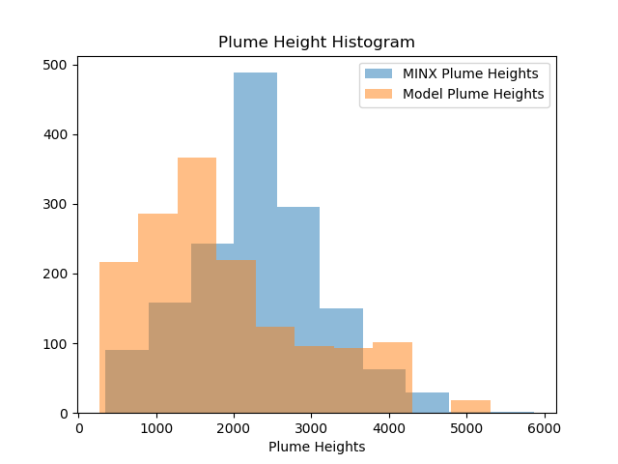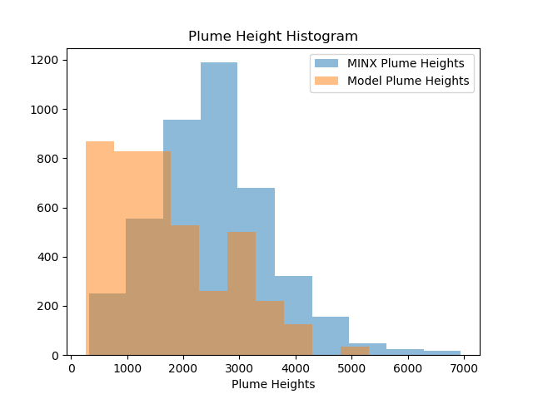

Images: Histogram of MINX and FireWork Plume Heights for distance 0-10km and 10-30km from the origin

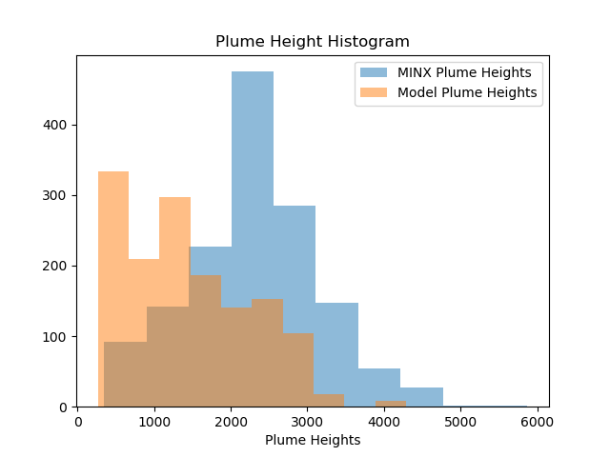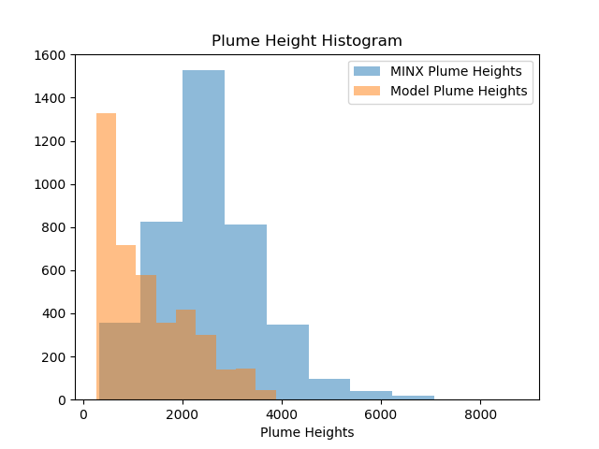

When viewing height distributions by distance, we see that CFFEPS has a tendency to overestimate plume heights for points closer to the origin. For distances 0-10 km, we see that FireWork does not much overestimation close to the origin. For both models, the individual plume heights are usually underestimations of the MINX plume heights, with more points being overestimated near the source of the plume.

Images: CFFEPS and FireWork (left to right) model plume heights overlain on MINX plume heights. There is a greater distribution of heights from the CFFEPS model plume heights and shows some overestimation. FireWork shows mostly underestimation.

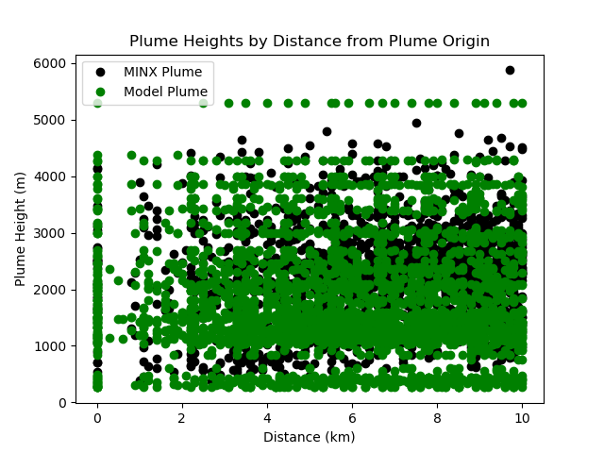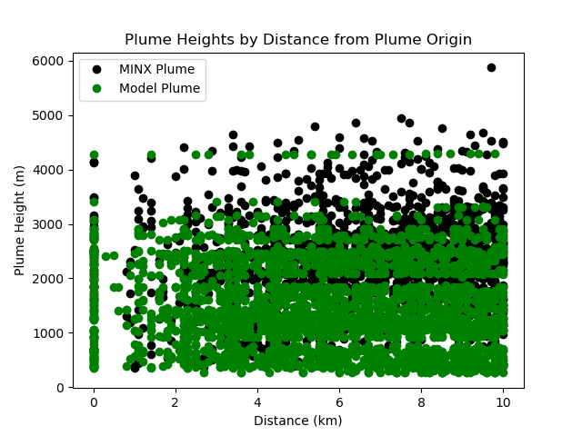

Images: CFFEPS and FireWork (left to right) model heights plotted against MINX plume heights.

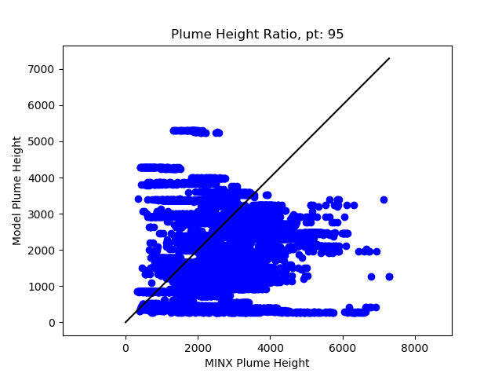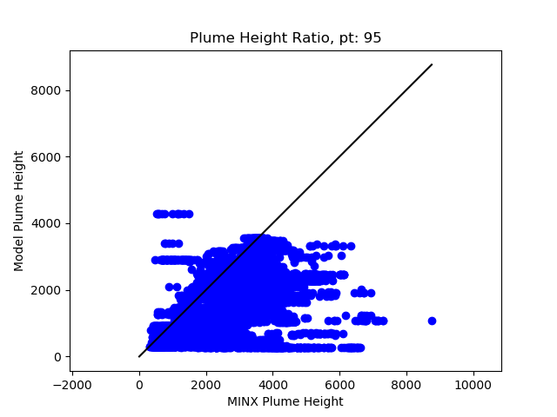

# Plume Heights by Biome

Biome breakdown is determined by MINX and is provided in the plume object that results from the MINX digitization. Biomes include a total possible list of <list of possible biomes>. The plumes that were digitized include plumes of biomes: Evergreen needleleaf, Grasslands, Mixed forest, Open shrublands, Savannas and Woody savannas.

The evergreen needleleaf biome shows primarily underestimation from the FireWork plume height results. For CFFEPS, we can see more points that are being overestimated. The largest overestimations take place in the 0-30 km distance from the origin. Both model results show underestimation for plumes of longer length. There is a greater spread of model to MINX plume heights for CFFEPS, whereas FireWork is appears to be underestimating the model consistently.

Images: CFFEPS and FireWork (left to right) plume heights. Note more scatter in CFFEPS plot

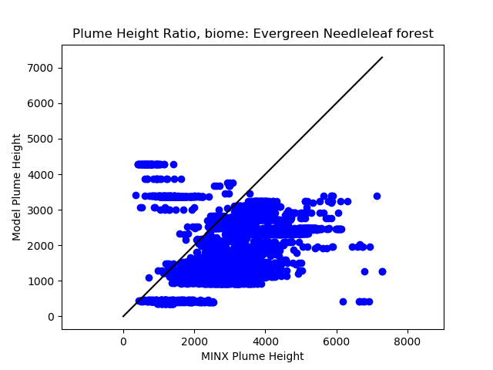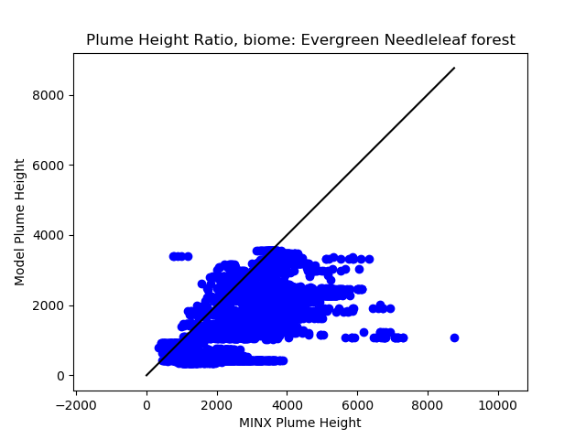

For the grasslands biome, we see that both models are similar in the underestimation of plume heights. However, there may not be enough plumes in the results to compare the two.

In the mixed forest biome, we see that the underestimation shown in FireWork is also seen in the CFFEPS results, with the exception of two spikes of overestimation near the 15 and 50km mark. This spike can be seen in the plume height comparison below:

Image: CFFEPS and MINX model heights for the mixed forest biome

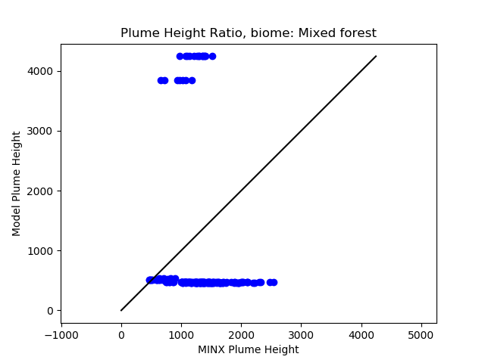

Open shrublands show that there is overestimation present from both model results. However, the overestimation in the cluster around the 20km mark is greater for CFFEPS than FireWork. Additionally, there appears to be a long, underestimated plume that is visible in the CFFEPS results that is not is not present in the FireWork results.

The savannas biome shows general underestimation for the FireWork results. For CFFEPS, there is more variation in plume height and more overestimation from the 0-30km distance from the origin. The plume heights more closely match the MINX plume heights for CFFEPS, where the plumes appear to be all at the roughly the same height for FireWork.

Images: CFFEPS and FireWork (left to right) model plume height comparison. Note that CFFEPS has plume heights passing through the 1:1 line, whereas the FireWork shows mostly low-lying plumes.

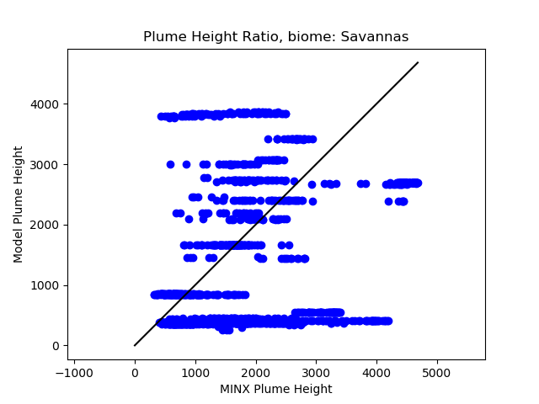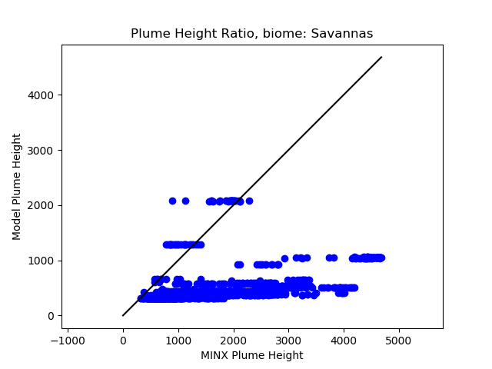

The two models return similar results for plume height in the woody savannas. There is overestimation from both models present, and a few underestimated plumes. CFFEPS appears to model a few longer plumes more closely than the FireWork model, though there is more overestimation present in the 0-20km range than FireWork.

# Plume Heights by Fuel

Plume height distributions in histograms show that the CFFEPS results more closely for fuel types: 102 and 108. FireWork results more closely match the height distributions for fuel types: 103 and 105. The remaining fuels are unclear in their height distributions.

*101 - Spruce-Lichen Woodland*

Plume height distribution shows a greater number of lower plume height points. Improvements or lack thereof from FireWork model is unclear.

*102 - Boreal Spruce*

The plume heights for the CFFEPS model results histogram matches more closely than the FireWork results. The plumes heights near the origin (0-30km) are better represented by the CFFEPS results.

*103 - Mature Jack or Lodgepole Pine*

The plume heights closer to the origin are both lower than and underestimating the MINX plume results. For the points closer to the origin, FireWork appears to match the MINX plume heights more closely.

*105 - Red and White Pine*

Insufficient number of plumes from the 95th percentile results to determine general trend. From few plumes available, it appears that CFFEPS plume heights underestimate less than the FireWork plume heights.

*108 - Leafless Aspen*

The plume height distribution of the CFFEPS model heights matches the MINX results more closely. Close to the origin, MINX plume heights that are higher are better modelled by the CFFEPS model. Both models show underestimation for longer plumes. Additionally, the mean percentage error from CFFEPS is lower than the FireWorks (15.3% to 38.7%).

*109 - Boreal Mixedwood-Leafless*

Distributions for both models do not match well with the MINX height distribution. For CFFEPS, there is more overestimation near the origin. Plume height mean of CFFEPS overestimates the MINX plume height mean by 20% while FireWork underestimates by 53%.

*116 -Grass*

Both models generally underestimate the plume heights.

*118 - Water*

Insufficient number of plumes with origin on/about water to have conclusion.

*120 - Bog*

Insufficient plumes to compare, but both models appear to underestimate the MINX plume heights.

*122 - Low_veg*

Unclear from plots to have clear conclusion. Plumes for this fuel are short and thus cannot show enough variation over distance to show how closely matching these plumes are.

Seems to be somewhat matching, perhaps plumes are very close to origin and model cannot show distribution of plume height with 10km grid.

# Plume Heights by Distance AND Fuel (101, 102)

CFFEPS has more variability close to the origin (0-30km) than FireWork. FireWork tends to underestimate more frequently than CFFEPS, resulting improved performance from CFFEPS for the 0-50km range.

*101 -50th and 95th percentile results*

In the range of 0-30 km from the origin, the results from CFFEPS indicate that the model more closely matches the MINX plume heights by way of more similar mean plume heights, smaller RMSD and a smaller absolute mean percentage error relative to results from FireWork. Note that the positive mean percentage error indicates a larger number of points of underestimating points, or very larger underestimations. The negative mean percentage error indicates that there is a large impact from the overestimated heights (ex. CFFEPS range 0-10km).

Similarly, in the 30-50km range, the CFFEPS mean heights are closer for the 50th percentile results. For both the 50th and 95th percentile, the RMSD is similar for both models, though CFFEPS has a smaller mean percentage error for both.

In the 50+ km range, we see that both of the models generally underestimate the plume height. The RMSD is smaller for the FireWork result, though the mean percentage error is variable. We also see that the correlation coefficients are significantly better for FireWork in comparison to CFFEPS, with FireWork having a best fit line with slope of ~0.8. This shows that FireWork is consistently underestimating, though is closely following the MINX plume height points, whereas there is more variation in the CFFEPS results.

*102 -50th and 95th percentile results*

In the range of 0-30km from the origin, we see that the mean plume height is closer to the MINX mean plume height for CFFEPS and the mean percentile error is smaller than the FireWork results. We do see that the RMSD is bigger for CFFEPS results, indicating that some of the over/underestimation may be greater. Correlation coefficients tend to be better for the FireWork results.

In the 30-50km range, we see that the mean is closer, mean percentile error and RMSD are smaller for the CFFEPS results.

In the 50km+ range, we see similar results to the 30-50km range where the mean is closer to the MINX plume heights, smaller mean percentile error and smaller RMSD compared to the FireWork results.

*Histogram Results*

The results in the histogram indicate that the CFFEPS results have greater variability close to the origin (NOTE: this is expected based on what we feed in to the GEMMACH model from CFFEPS, vs FireWork which the zPlume is more concentrated lower to the ground). Additionally, the histograms indicate that the plume heights from the CFFEPS results match the MINX plume heights more closely match in comparison to the FireWork results. This variability is carried throughout for longer plumes.

<INCLUDE CHARTS>

# Time Series

Image: Time series illustrating the heights of plumes at their origin

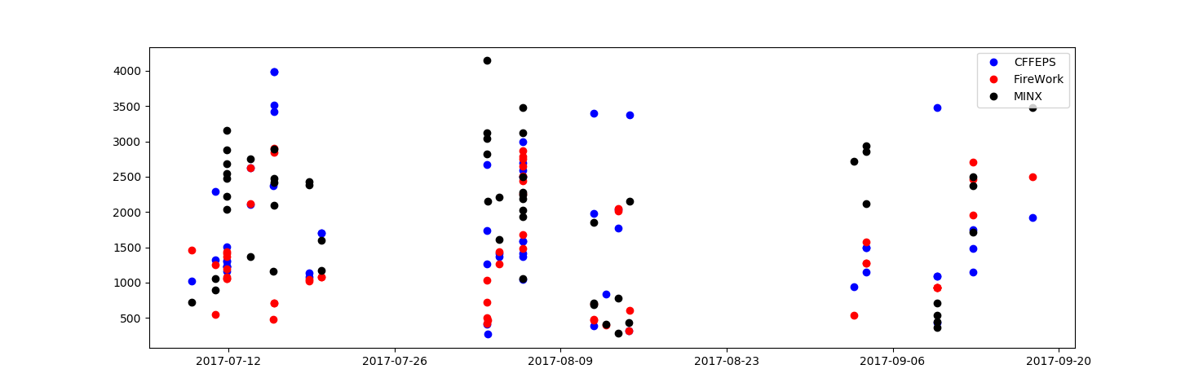

We see in the time series that CFFEPS has a tendency to have higher plume heights at the origin of plumes, though there are also instances of underestimations that are worse than the FireWork plume height in September.

# Case Studies

Plumes with points over 20,000m for CFFEPS were removed for the overall discussion as they contributed to some misrepresentation of the overall data. When taking a closer look at these plumes that were removed, we find the following. All five plumes that had plume heights over were fires from June 2, 2017 in the Yukon Territory. These plumes had their plume heights determined using local maxima of PM2.5 values from the model. For CFFEPS, the average PM2.5 value that indicated the plume location was found to be 5.9ppm. It is likely that the true plume is either not modelled or has been removed when removing anthropogenic sources of PM2.5. As such, the small levels of PM2.5 detected are possibly from another nearby plume.

We see in two of the plumes, part of the model is somewhat close to the MINX plume height and is possibly the model plume we’d like to look at, but suddenly increases – possibly another plume obscuring the one of interest.

Images: Scatter plots of two of the five plumes that also show model plume heights close to the MINX plume height indicate another source of PM2.5 may be interfering with model results.

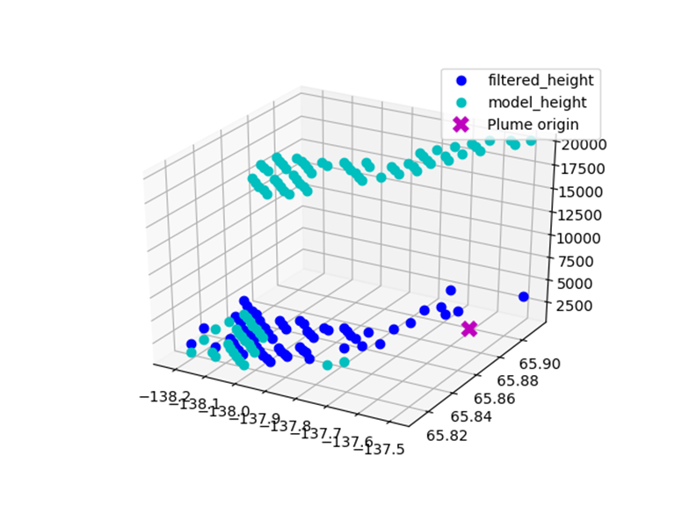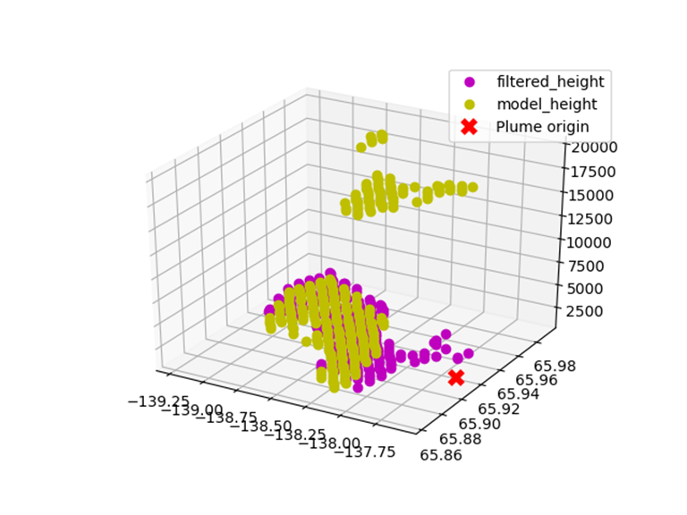

## Cluster of plumes in August

This cluster of plumes are from August 13, 2017 in the Northwest Territories. The plumes appear to be wispy, though were successfully digitized using the red band, and are close to the ground. The plumes are of type 101 and 102, and biome open shrublands and savannas.

CFFEPS overestimates three of the four plumes found in this group, but still performs better than FireWork with lower RMSD and mean percentage error. One plume emulates the shape of the MINX plume, though still overestimates.

Image: CFFEPS plume which most closely matches the MINX plume heights from the four plumes in the Aug 13 group

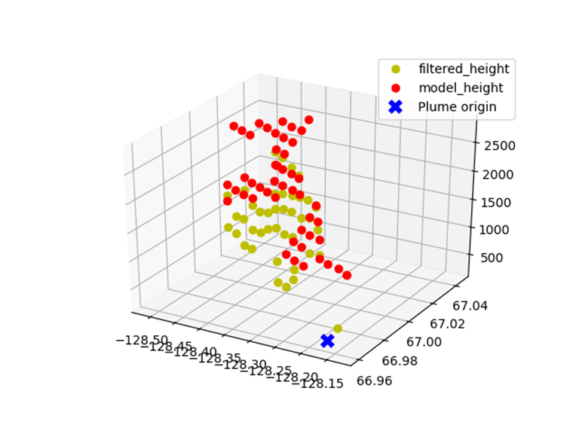

The overestimation from both FireWork and CFFEPS models may be explained by the variable injection heights provided to the model. However, these plumes may also be partially misrepresented by the thin layer of cloud cover that appears to be present in the MISR imagery. This may be due to the choice of using a red band to digitize or the thin cloud cover that may interfere with the plume height detection.

Another possible explanation is that due to the short length of the plumes, it is possible that both models represented the plume poorly.

## Overlapping Plumes in September

These plumes are found on September 3, 2017, found in the corner of British Columbia next to Alberta and the United States of America. The plumes were digitized using the red band and are of fuel types 102 and 109, and biomes of type grasslands and evergreen forest. Plumes discussed can be found here: C:\Users\DongE\Documents\ECCC\Projects\In Progress\MINX\elisaMINX\Analysis\Sept_094211\094211

Both CFFEPS and FireWork underestimate the MINX plume heights. In the individual scatter plots, we see that the model plumes returned appear to have components from other interfering plumes. This is not unexpected, as other plumes may have higher PM2.5 and interfere with the model results. It is also possible that the underestimation is due to the coarseness of the model grid, where the rise in plume height close to the origin is not captured in the model, hence the ‘jump’ from lower to higher plume height. In the case of a few plumes, we see that CFFEPS represents the expected trend better. For example, in plume O094211-B051-SOWR07, we see that the CFFEPS plume is near the origin, increases, then drops off slightly similar to the MINX digitized plume. The plume heights that are low lying likely represent another plume of higher concentration. This is also modelled remarkably well in the FireWork result.

In this group of plumes, the FireWork and CFFEPS results are fairly similar with the exception of R07 where we see potential interference from another plume in CFFEPS. Underestimation of model results are in line with previous observations and may be exacerbated by the impact of overlying plumes.

Image: Digitized plume from MINX, then CFFEPS and FireWork (left to right)

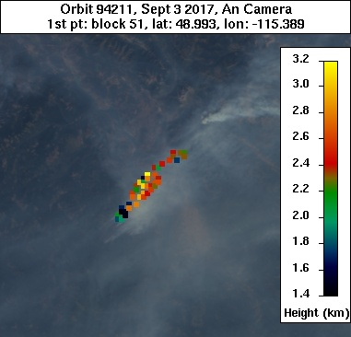

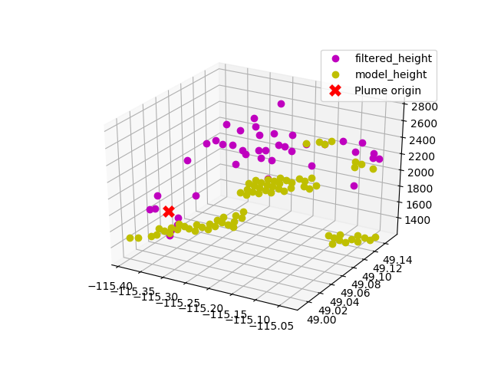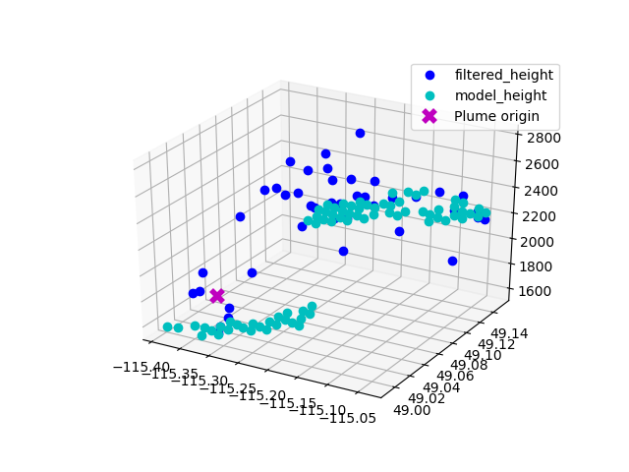

NOTE: When picking out the model plume height, if there are interfering plumes (ie. Plumes that overlap each other), we expect to get the plume with highest PM2.5 concentration. This value is produced by a variety of factors (size of fire, fuel, burn time, etc), so we cannot always assume that the model plume returned is the one closest to the origin of the fire.

# Next Steps

Elisa recommended next steps would be to compare results from the MINX plume heights to a higher resolution models for both CFFEPS and FireWork. Due to the length of most plumes, most plumes are captured within 5 grid cells of the model, which may be insufficient in resolution to see the details of the plume, and are more of an ‘averaging’ for the length along the plume. Alternatively, the MINX plumes could be overlain with the model results and sorted into the same grids, then compare the averaged MINX height for the model grid to the model plume height value.

A new model plume height method can be created to better retrieve the maximum plume height. Currently the vertical resolution of the model is also somewhat poor (sometimes a few hundred meters between cells) and is picking out the densest part of the plume, which may not be the maximum height of the plume at a given location.

A second method to compare model plume heights to satellite data is currently in the works! CALIOP retrievals should be able to pick out aerosol heights. In relation to fire hotspots detected by MODIS, we should be able to compare the aerosol heights (assuming they represent fire plumes) and compare them to corresponding model plume heights.

# Appendix

## Results

Results, statistics, plots can be found in the following locations:

FireWork - <https://hpfx.science.gc.ca/~eld001/MINXResults/FW-GM_start00/ops_postCanFilt/plumeApr_Oct/>

CFFEPS - <https://hpfx.science.gc.ca/~eld001/MINXResults/CF-GM_start00/ops_postCanFilt/plumeApr_Oct/>

## Definitions/Details

For some words that may be unclear.

**FirePixel/HotSpot** - Location of hotspot as provided by a firepixel file from the MODIS instrument

* Can be visually identified in MINX software as red pixels in overlay
* Has associated lon/lat, FRP, confidence level, etc

**Fuel Types**  - fuel types and codes are from the CWFIS fuel types

101 = C1, Spruce-Lichen Woodland

102 = C2, Boreal Spruce

103 = C3, Mature Jack or Lodgepole Pine

104 = C4, Immature Jack or Lodgepole Pine

105 = C5, Red and White Pine

106 = C6, Conifer Plantation

107 = C7, Poderosa Pine--Douglas-Fir

108 = D1, Leafless Aspen

109 = M1, Boreal Mixedwood-Leafless

113 = S1, Jack or Lodgepole Pine Slash

114 = S2, White Sprice-Balsam Slash

116 = O1, Grass

118 = Water

119 = NF (non fuel)

120 = Bog

121 = Urban

122 = Low_veg (this refers to tundra, alpine, and other areas with very low ground cover)

See fuel type conversion here: <http://cwfis.cfs.nrcan.gc.ca/background/fueltypes/c1>

**MINX/MINX4** – digitization software that loads MODIS and MISR data. User visually inspects images and draws a circle or line indicating the plume location. Results in several images and a plume text file being saved.

**MINX plume** – text file results from the MINX4 digitization. Height of plume is one of the values used to compare to model height.

**Model Plume** – plume retrieved from model or two models (fire+ anthropogenic sources and just anthropogenic sources where only the fire impacts on PM2.5 are retained). The models used are CFFEPS (model currently in development), FireWork (operational model) and GEMMACH (CFFEPS and FireWork feed into GEMMACH. In this case, GEMMACH represents strictly anthropogenic sources of PM2.5).

* Either CFFEPS - GEMMACH or FireWork - GEMMACH
* For each lon/lat point in the digitized plume, a corresponding height was found in the model
* The height of the plume was determined by the greatest PM2.5 values for
  + A local maximum
  + Greater than a threshold value
  + 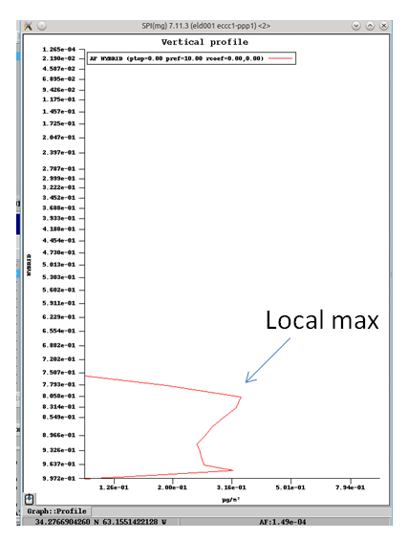

**Origin** - starting point of digitization (ie. The first point that goes down when digitizing). Often just to the side of the hotspot as seen in MINX in the opposite direction of the plume

**Plume (Valid) Pairs -** Total number of paired points within the plume that are in the given result

* A paired point is for each lon/lat in the digitized plume, there is a corresponding plume height from both the MINX digitized results and the model results
* Does not include points (see pairs dropped in statistcs) that either the model and the minx plume heights do not have a value for

**Plume selection:**

* Percentile is by FRP for individual hotspots collecting over Canada for the time duration April 1, 2017 – October 31, 2017
* Note that plumes often contain more than 1 hotspot, so may not be the best way to look at breakdown
* Confidence level:
  + Only looked at firepixels greater than 60 confidence (default MINX looks at 40)
* Percentile:
  + Default threshold to look at percentile was 50
* Only included plumes with origins in Canada, some interesting plumes in the US may or may not have impacts on the model results in Canada (note that the model includes some areas outside of the canfuels map)

## MINX and preMINX setup

To run scripts associated with downloading, digitizing and processing plumes

Anaconda installation/setup

1. Get the latest version of anaconda, this should give you a folder called .conda

. ssmuse-sh -x hpco/exp/mib002/anaconda2/anaconda2-5.0.1-hpcobeta2

1. Softlink .conda/pkgs and .conda/env to somewhere with a lot of space
2. Create a new environment with desired modules (or install these after)  
   conda create -n py2-1.0 python=2.7 anaconda <module 2> <module 3> <etc>
3. Enter the new environment  
   source activate py2-1.0
4. Use anaconda to install some packages if you don't have them:  
   conda install matplotlib==1.3.1  
   conda install numpy==1.14.0  
   conda install netCDF4==1.3.1  
   conda install scipy==1.0.0  
   conda install requests==2.18.4  
   conda install -c anaconda basemap  
   conda install gdal  
     
   To check whether or not you have the packages, try:  
   conda list
5. Try pip install for the other packages (anaconda doesn't have all of them):  
   pip install python-hdf4==0.9  
   pip install simplekml==1.3.0  
   pip install pyorbital==1.1.1
6. If that doesn't work, you have to copy over the appropriate folders from:  
   /fs/site2/dev/eccc/aq/r1/eld001/condaPkgs/ to wherever the .conda/pkgs softlinked folder is  
   The folders you want are (not sure if dist-info is necessary, but just in case…):  
   python_hdf4-0.9.dist-info  
   pyhdf  
   pyorbital-v1.2.0.dist-info  
   pyorbital  
   simplekml-1.3.0.dist-info  
   simplekml
7. Update the .profile.d/interactive/post file to point to the appropriate conda package location and MINX folders by adding the lines:

# MINX software

export PATH=$PATH:/space/hall2/sitestore/eccc/aq/r1/nod001/MINX/MINX4

#NOTE: This can be replaced with your MINX4 download path

# Plume Height computer programs requirements

export PATH=$PATH:/fs/home/fs1/eccc/aq/arqi/mas001/computer_programs/python/MINX

export PYTHONPATH=$PYTHONPATH:/fs/home/fs1/eccc/aq/arqi/mas001/computer_programs/python/MINX

export PPP_CONFIG_DIR=/fs/home/fs1/eccc/aq/arqi/mas001/computer_programs/python/MINX/data

# Must include this to import MINX modules directly, else must import MINX.postMINX

export PYTHONPATH=$PYTHONPATH:/fs/home/fs1/eccc/aq/arqi/mas001/computer_programs/python/MINX/MINX

# Point to conda packages folder, below is an example

export PYTHONPATH=$PYTHONPATH:/fs/site2/dev/eccc/aq/r1/eld001/condaPkgs

# Include path to elisa scripts (includes postMINX processing, plume analysis, etc)

export PYTHONPATH=$PYTHONPATH:/fs/home/fs1/eccc/aq/arqi/eld001/scripts

1. Restart and try running this in a test folder (will create a bunch of files and folders) to check if installation and setup worked:  
   preMINX -d 2017.09.04 -L -121.6406 -97.3125 48.2343 60.75 -u elisadong -p elisaPass1 --grandir ./granules
2. You can now run preMINX, MINX4, postMINX and related programs!
3. To exit the environment, in command line, type:  
     
   source deactivate

## Caveats

Here is a list of concerns/things to keep in mind while looking at the results.

**Fuel types:**

* Some plumes are on fuel type 118 - water. While some fires may be close to water, it is unlikely any of the origins were present on a water surface. Perhaps the results of the MINX origins are not very accurate, so breakdown by fuel may be less accurate than liked.
* Majority of plumes are in central and western Canada, results in not having a lot of data for certain plume types.
* Grass (O1) is not broken down into subtypes, depending on what is provided, may see some variance from Apr vs Sept/Oct.
* Some types of fuel listed in the CWFIS fuels are not present on the Canadian fuels map. Uncertain if this is of concern or not. The map posted on the CWFIS site also does not have fuels S3, M2, M3, and M4.

CWFIS fuels map:  
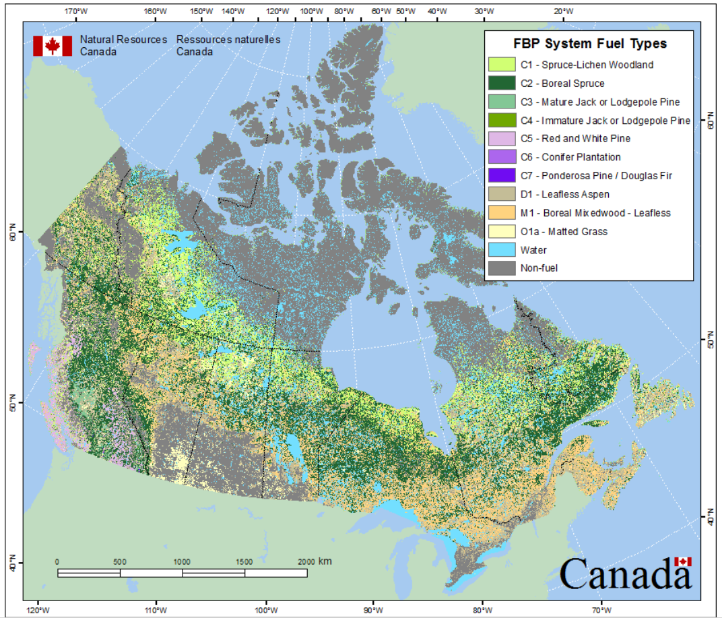

Compared to,

Map generated using canfuels files:

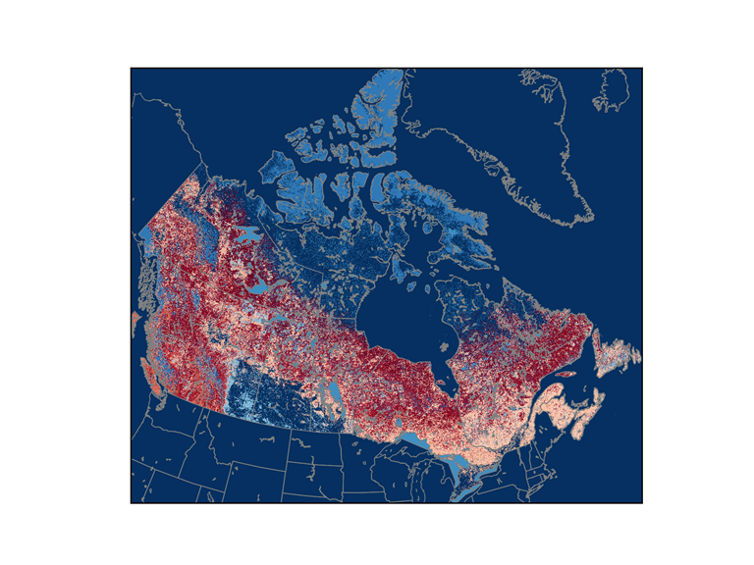

**MISR Satellite:**

* Passes over equator at 10:30 am.
* Misses the major fire development (afternoons)

**Model Plume Heights:**

* Resolution: The models used in this report had a resolution with grid of 10km. Many of the plumes are under 150km long, and thus, the models can only represent the plumes in 10km resolution. Variation at smaller levels do not show up in the results and thus looking at a point by point ratio of the model vs the MINX plume heights may not be the best manner in doing so. The impact of this can be seen in the plume height plots by distance, where the model results are comparatively linear
* NOTE: In this study, the threshold value was set to 0ppm as the only PM2.5 values present should be from the fire, and not from anthropogenic source
* NOTE: the height retrieved can be considered to be the centerline of the fire plume. The real height should be the top of the plume.
* NOTE: The vertical resolution of the model varies depending on hybrid level. There may be some under estimation of plumes at certain elevations (up to ~500m) when determining the height of the plume. See <https://hpfx.science.gc.ca/~jac001/TMP/Runmod.RAQDPS.out>
* There exist other methods in which we can determine the 'plume height' from the model

**MINX Plumes:**

* Includes plumes that are within the scope of the study
* Used either red or blue band to retrieve data (see procedure)
* Used image matcher: small

**Binning by percentile:**

* Did not factor in confidence level, looked at all FirePixels retrieved from MODIS
* Fairly arbitrary method of filtering out plumes since total FRP for plumes varies depending on how many hotspots were circled

## Procedure

1. Downloaded MODIS/MISR data using preMINX commands.  
   April

preMINX -L -142.0 -50.7 42.0 83.0 -d 2017.04.01 2017.04.30 -u elisadong -p elisaPass1 --grandir ./granules --debug

May

preMINX -L -142.0 -50.7 42.0 83.0 -d 2017.05.01 2017.05.31 -u elisadong -p elisaPass1 --grandir ./granules --debug

June

preMINX -L -142.0 -50.7 42.0 83.0 -d 2017.06.01 2017.06.30 -u elisadong -p elisaPass1 --grandir ./granules --debug

July

preMINX -L -142.0 -50.7 42.0 83.0 -d 2017.07.01 2017.07.31 -u elisadong -p elisaPass1 --grandir ./granules --debug

August

preMINX -L -142.0 -50.7 42.0 83.0 -d 2017.08.01 2017.08.31 -u elisadong -p elisaPass1 --grandir ./granules --debug

Sept

preMINX -L -142.0 -50.7 42.0 83.0 -d 2017.09.01 2017.09.30 -u elisadong -p elisaPass1 --grandir ./granules --debug

Oct

preMINX -L -142.0 -50.7 42.0 83.0 -d 2017.10.01 2017.10.31 -u elisadong -p elisaPass1 --grandir ./granules --debug

1. Digitized plumes using MINX4 software.
   1. Command line: MINX4
   2. Adjust plume project directory to directory where you want your outputs to be saved
   3. Load MODIS FirePixels into visual display
   4. Digitize plumes located by FirePixels using ‘small image matcher’
   5. Discard ‘poor’ plumes
   6. Switch to blue band as needed
2. Filter out plumes that are not in Canada by checking whether or not the fuel type for a plume is 255 (no data). Note that this should be done prior to digitization in future instances
3. Process plumes using plumeAnalysis.py. This function borrows from postMINX.py and niceUtilities.py and heavily relies on the saving of an existing plume object to a pickle file to speed up the process. Sample command lines can be found in binPercentiles.py (outdated) and exBinPercentiles.py. Results from plumeAnalysis are statistics and plots (general and specific to distance, fuel and biome). Additional functions have been written such as plmTimeSeries.py to investigate specific things (such as a time series). Plots per plume can be directly created using postMINX.py.